VIDYABHARTI TRUST COLLEGE OF BUSINESS, COMPUTER-SCIENCE & RESEARCH. UMRAKH



**PROJECT REPORT**

*BACHELOR OF COMPUTER APPLICATION*

(B.C.A)

SEM : V

YEAR: 2022 - 2023

**Online Bakery Management System**

GUIDED BY: SUBMITTED BY:

**MISS. MOHINI PATEL Mr. JAY H PATEL**

VIDYABHARTI TRUST COLLEGE OF BUSINESS, COMPUTER-SCIENCE & RESEARCH, UMRAKH.

|  |  |
| --- | --- |
|  | Vidyabharti Trust College of Business, Computer-Science & Research. Umrakh  At & Po: Umrakh, Ta: Bardoli, Dist: Surat – 394345, Gujarat, INDIA. |



CERTIFICATE

This is to certify that Mr. **Jay Hiteshkumar Patel** Exam Seat Number: **3052** has satisfactorily completed his project work entitled **Online Bakery Management** as a partial fulfillment of the requirements for **5th** ***Semester – B.C.A. (Bachelor of Computer Application)***, during the academic Year 2012 - 2023.

Date: **Dr. Snehal H. Mistry**

**Principal**

Place: **Vidyabharti Trust College of Business, Computer-Science & Research.**

**Umrakh, Bardoli, Surat**

**PROJECT OF B.C.A.**

Academic Year_2022-23_

Approved by: ____________________

(Examiners)

|  |  |
| --- | --- |
| **Table Of Content** | |
| CHAPTERS | PARTICULARS |
| **1** | Introduction  1.1 Project Description  1.2 Project Profile  1.3 Objective |
| **2** | System Design |
| **3** | UML Diagram  3.1 USECASE Diagram  3.2 Activity Diagram |
| **4** | Database Design |
| **5** | Interface Design |
| **6** | References |

**1.Introduction**

**1.1:Project Description:**

**Overview:**

* The Bakery Management System. The system requires user credentials in order for the management can access the data, features, and functionalities.
* Manage the products, stocks, and categories.
* It has also a feature that generates a printable receipt and date-wise sales report.

**Advantages:**

* Manage the products, stocks, and categories. They also have the privilege to access and manage all the features and functionalities of what the system does.
* A Point of Sale feature to manage the shop's daily sales.

**List Of Modules:**

1. **Category:** Allows To Add And Manage the details of Category regarding category.
2. **Product:** Allows To Add And Manage the details of Product regarding category, Product code, ProductName, Price and Description.
3. **User:** Allows To Add and Mange Users(**Cashiers**).
4. **Stock:** Allows To Add and Manage the details of Product regarding product Qty, product exp date.

**1.2:Project Profile:**

|  |  |
| --- | --- |
| Project Title: | Online Bakery Management System |
| Frontend: | HTML,PHP,CSS |
| Backend: | MYSQL |
| Editors: | VS Code, Notepad++ |
| Submitted To: | Mohini Patel |

**1.3:Objectives:**

* Online Bakery Management System is Designed To manage activities related to daily Sales, Stock manage, product manage.
* It become through for Bakery owner to manage all Bakery work Manually.
* To reduce manual work, A Bakery Management System can help to make day-to-day Bakery related activities easier.
* You also track total selling of a specific time period, last week or a present day.
* Through this System it’s Possible to see the old invoices and product within a Second.

**2.System Design**

**2.1:UseCase Design**

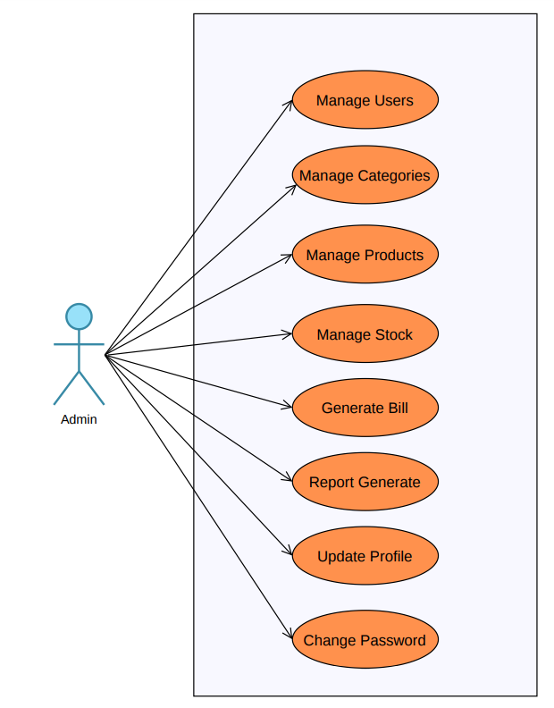

**2.2: Activity Diagram Of BMS**

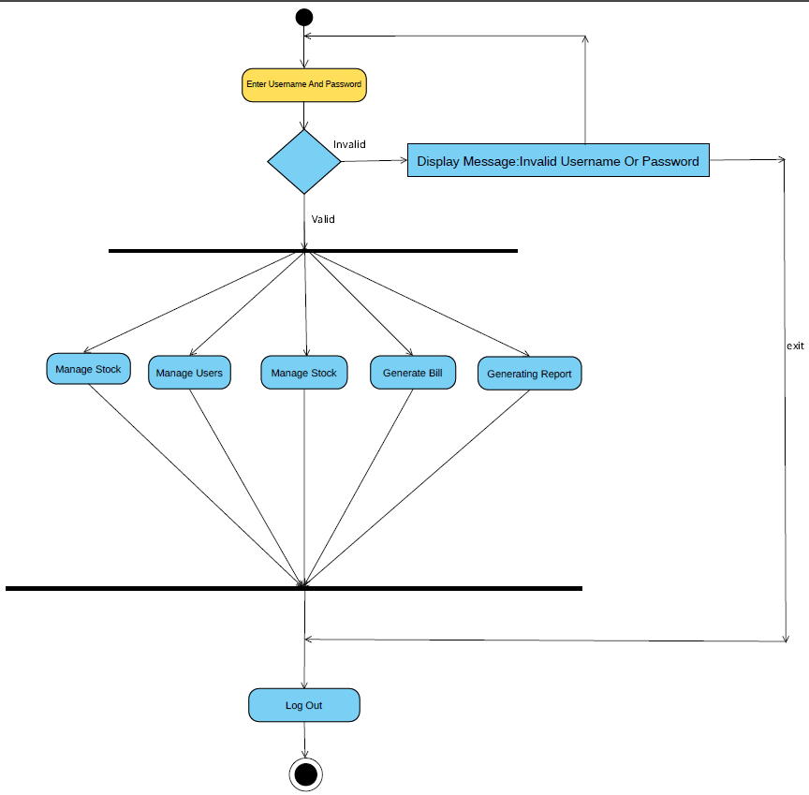

**Maintain Users:**

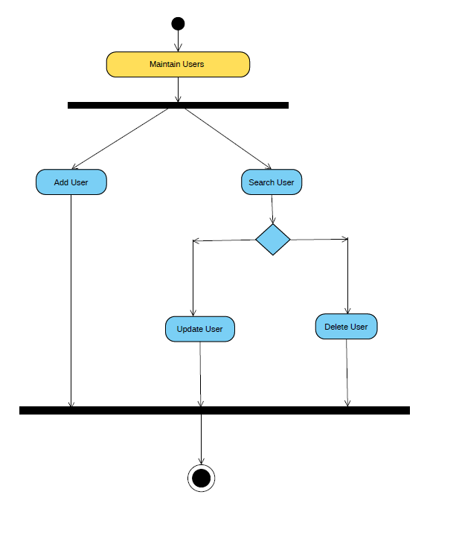

**Manage Product:**

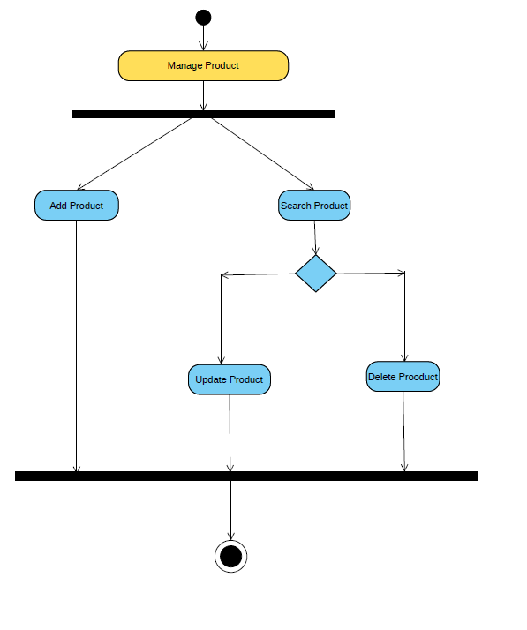

**2.3 Activity Diagram:**

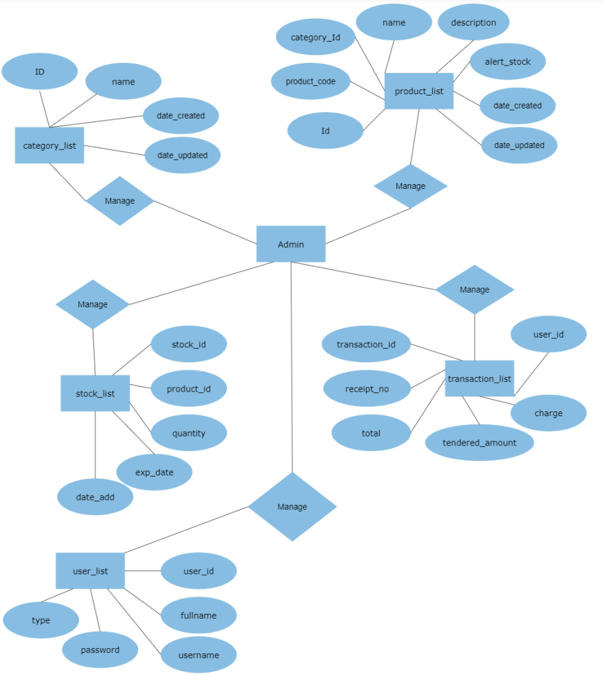

**3.Database Design**

**1.**user_list

|  |  |  |
| --- | --- | --- |
| No | Field Name | Datatype |
| 1 | user_id(PK) | Int(30) |
| 2 | fullname | text |
| 3 | username | text |
| 4 | password | text |
| 5 | type | Int(30) |
| 6 | date_created | timestamp |

**2.**category_list

|  |  |  |
| --- | --- | --- |
| No | Field Name | Datatype |
| 1 | category_id(PK) | Int(30) |
| 2 | name | text |
| 3 | description | text |
| 4 | date_created | timestamp |
| 5 | date_updated | timestamp |

**3.**stock_list

|  |  |  |
| --- | --- | --- |
| No | Field Name | Datatype |
| 1 | stock_id(PK) | Int(30) |
| 2 | Product_id(FK) | Int(30) |
| 3 | quantity | double |
| 4 | expiry_date | datetime |
| 5 | date_added | timestamp |

**4.**Product_list

|  |  |  |
| --- | --- | --- |
| No | Field Name | Datatype |
| 1 | product_id(PK) | Int(30) |
| 2 | product_code | text |
| 3 | category_id(FK) | Int(30) |
| 4 | name | text |
| 5 | description | text |
| 6 | price | double |
| 7 | alert_restock | double |
| 8 | date_created | datetime |
| 9 | date_updated | current timestamp |

**5.**Transaction_list

|  |  |  |
| --- | --- | --- |
| No | Field Name | Datatype |
| 1 | transaction_id(PK) | Int(30) |
| 2 | receipt_no | text |
| 3 | total | double |
| 4 | tendered_amount | double |
| 5 | change | double |
| 6 | user_id(FK) | Int(30) |
| 7 | date_added | timestamp |

**4.Interface Design**

**Login Page:**

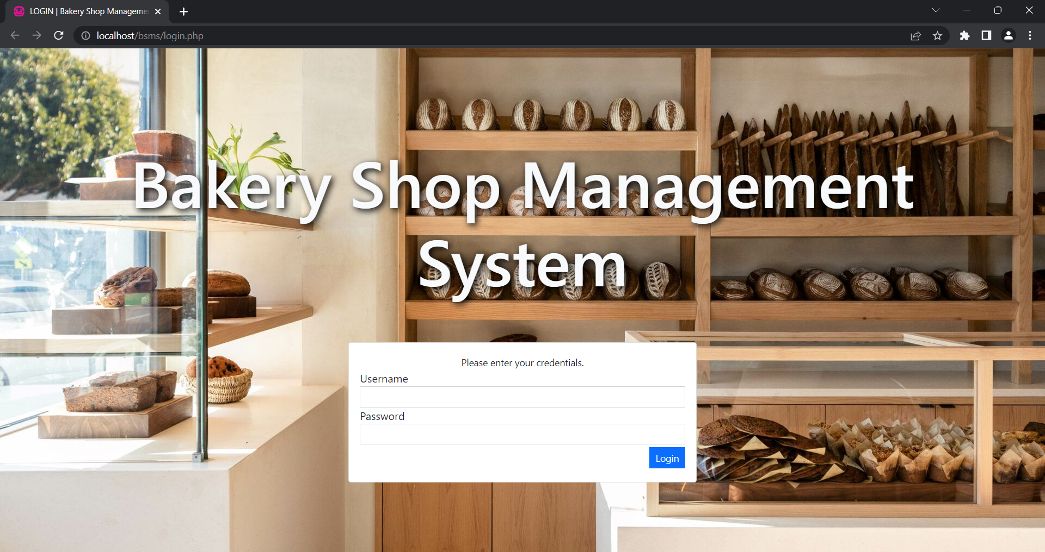

**Main Page:**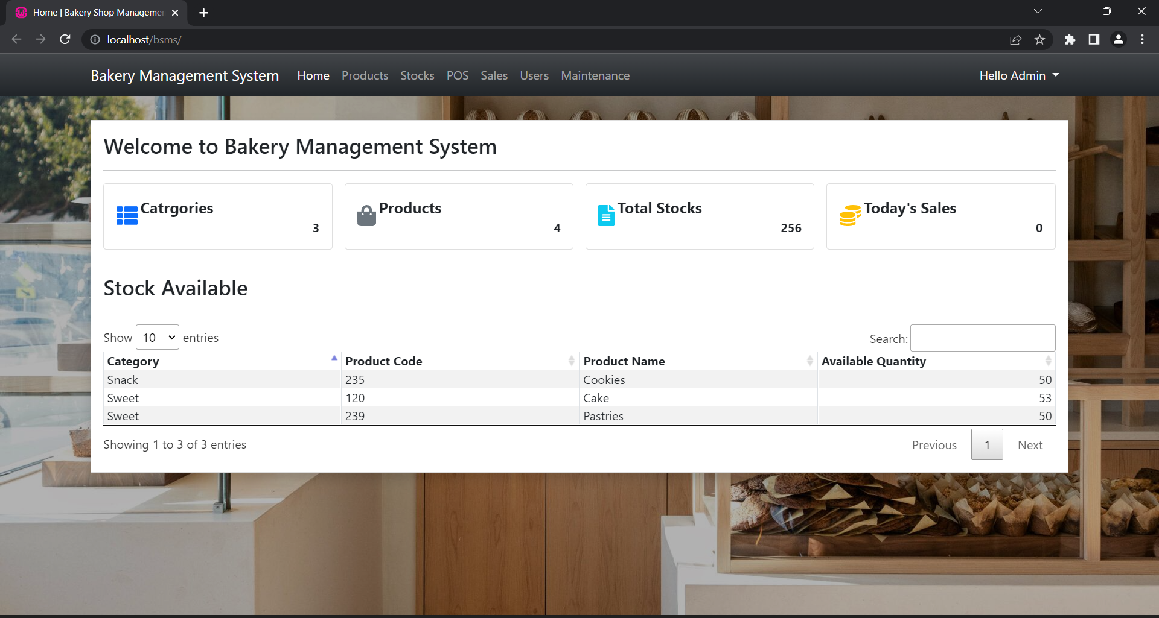

**Admin Profile**

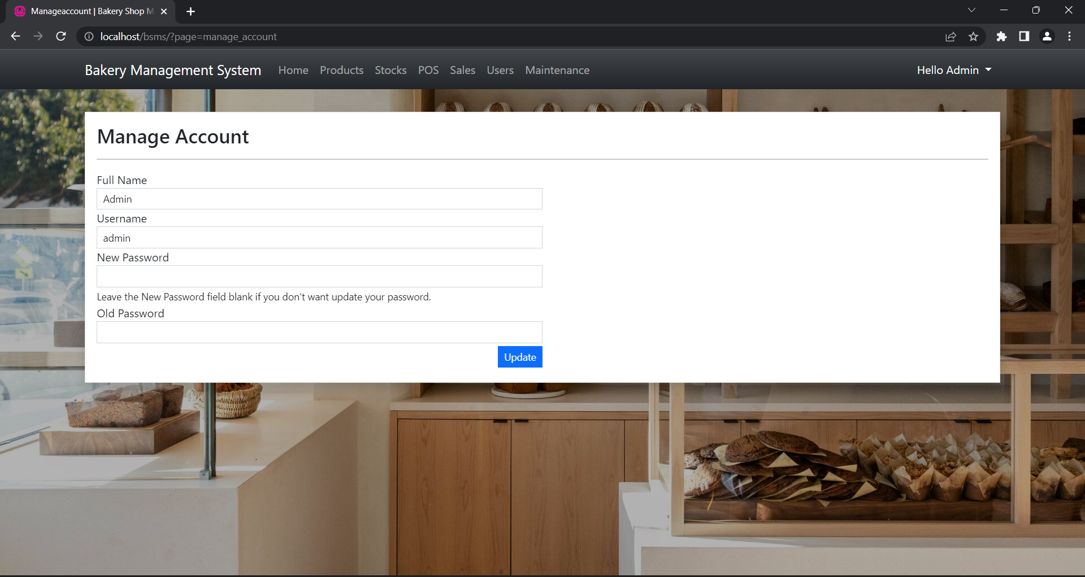

**Add Product Page**

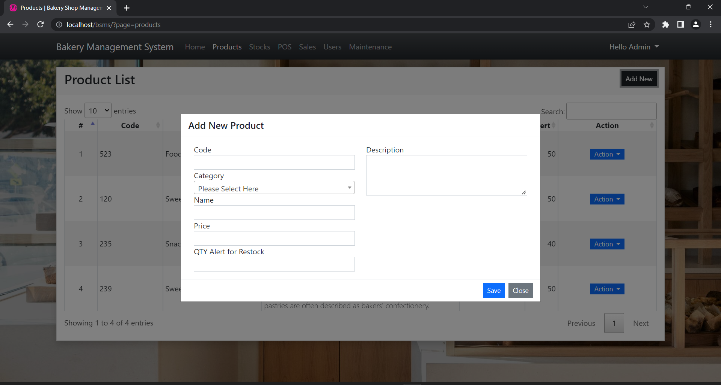

**Add Stock Page**

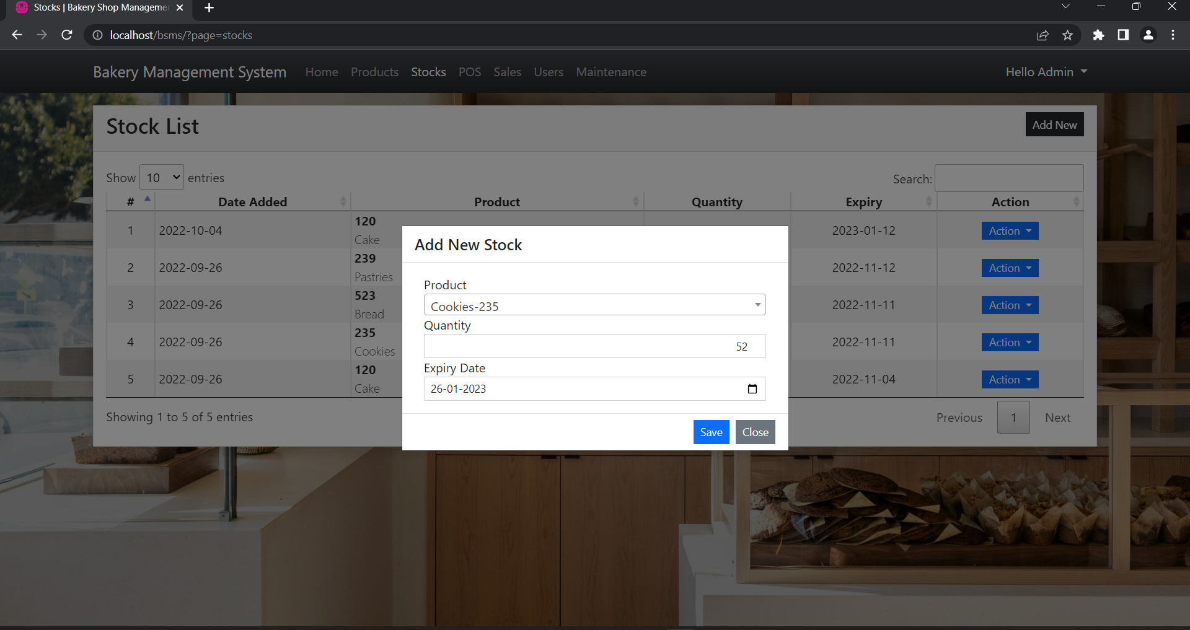

**Add Category Page**

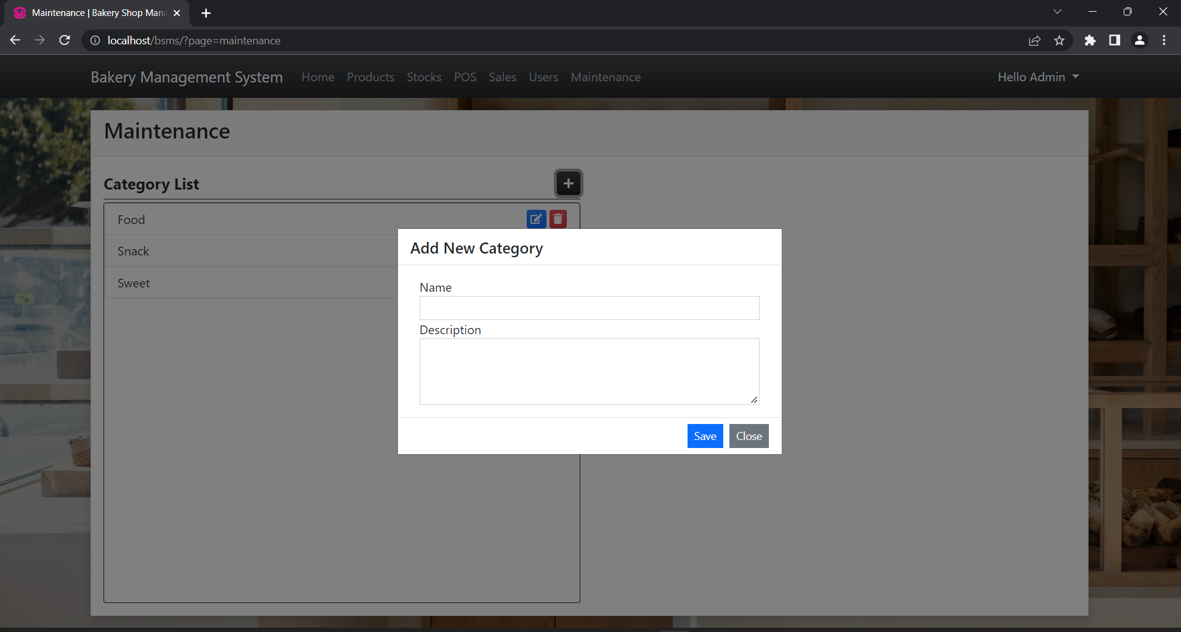

**Manage Product Page**

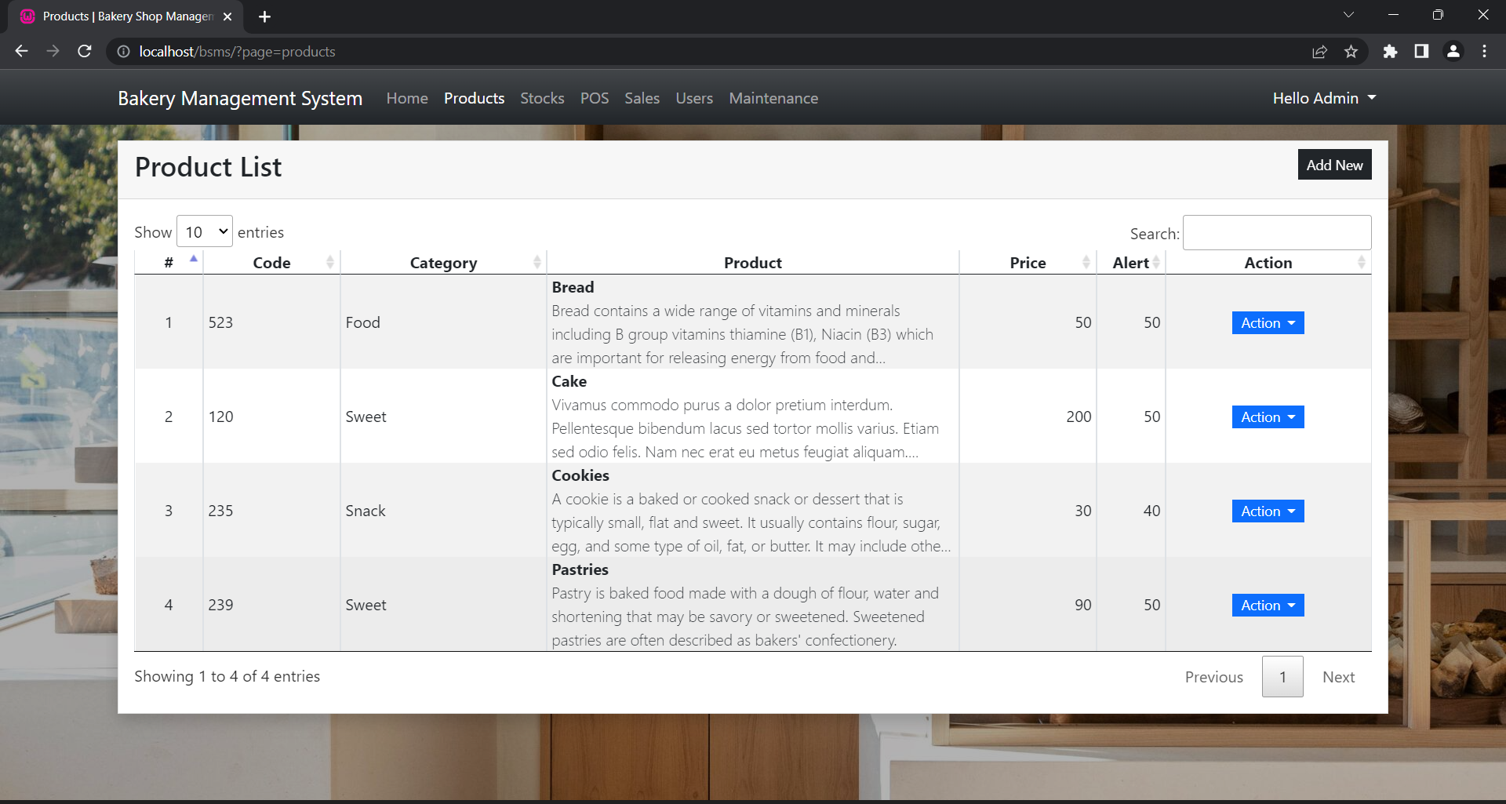

**Manage Stock Page**

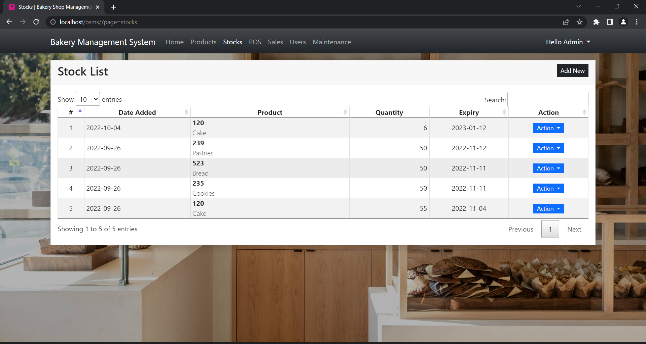

**Manage User Page**

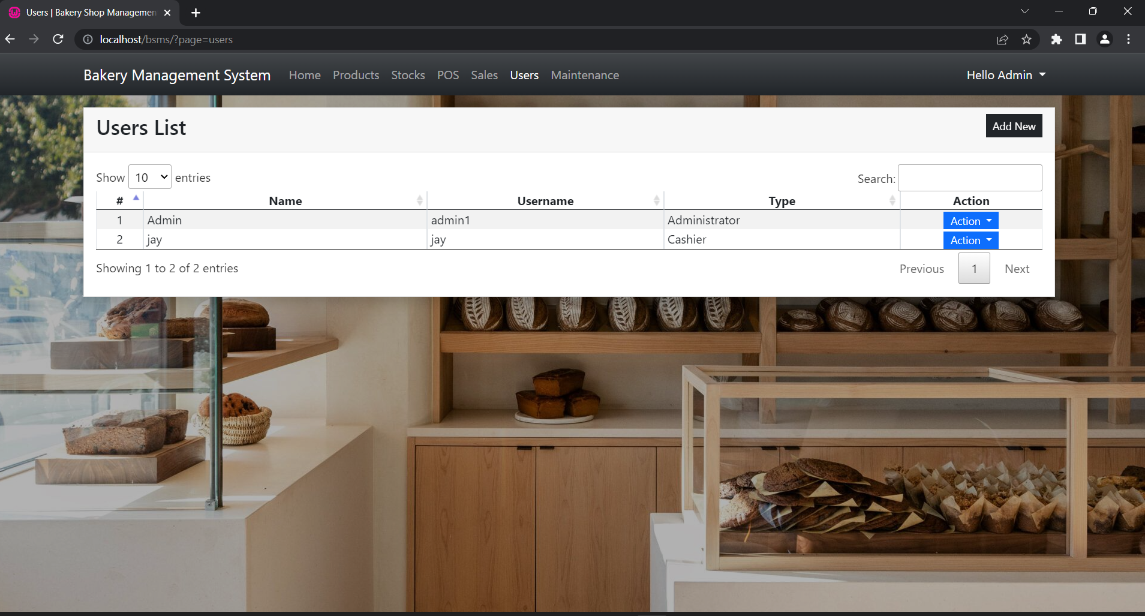

**Sales Report Page**

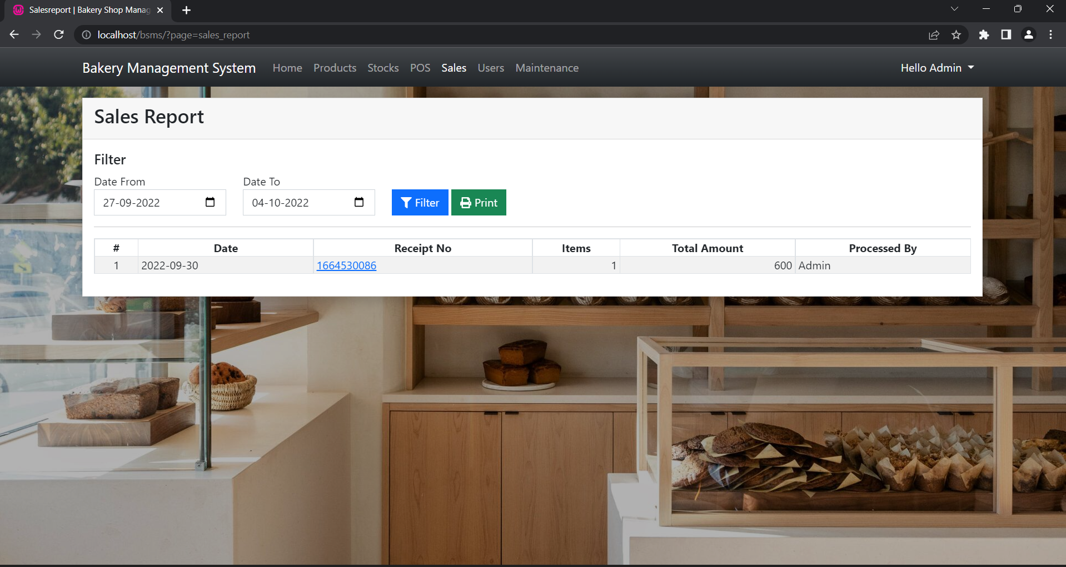

**Manage Category**

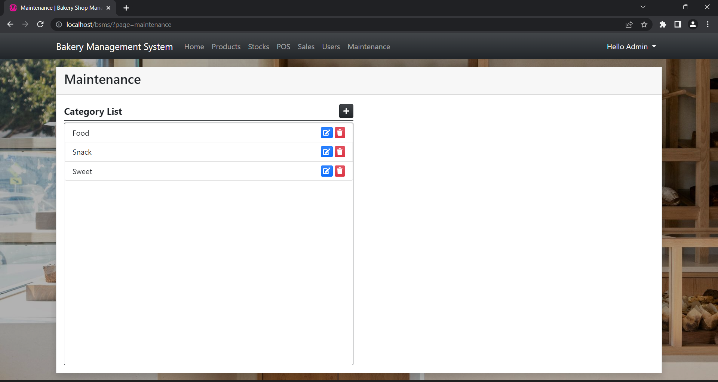

**Generate Bill Page**

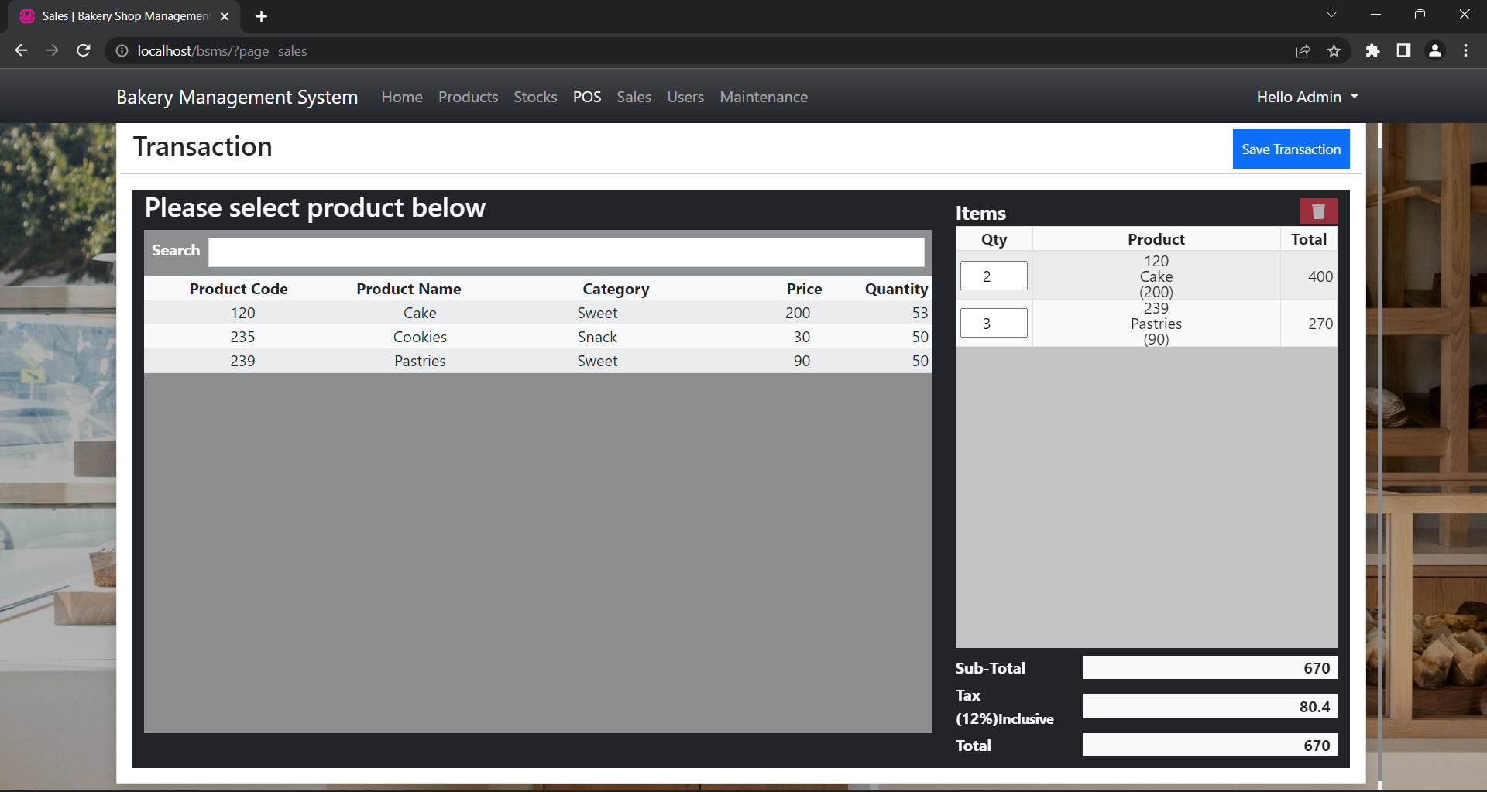

**5.References**

|  |  |
| --- | --- |
| Reference Detail | |
| Book: | Software Engineering-A-Practitioners Approach Pressman 5Th-Ed **-McGraw Hill** |
| Code: | <https://www.php.net/manual/en/>  <https://www.w3schools.com/php/> |
| Diagrams | <https://smartdraw.com/> |
| Documentation: | Ms Word |